General Information

[Title]
by
[Your Name]

[Story World Name]

Logline:

Pitch:

Setting:

Tone:

Instructions

I’m going to assume if you’ve downloaded this template that you are of above average intelligence (and probably attractiveness), so will try and keep these instructions brief since I’m hoping it’s all fairly intuitive.

- This is meant to be a living document that you fill out whenever you need to. Add, move, or delete whole sections to make it your own.
- That said, I would suggest that you update the Minor Characters, Geography, and Minor Locations fairly frequently since those are the sections you are most likely to come up with during your writing sessions. Five minutes spent filling out your bible at the end of a writing session can save you hours of searching when you need this info later.
- “BLANKs” are parts of the template that occur after the first three that I provide and are meant to be copy and pasted over and over again. For example, instead of filling out the BLANK for your fourth major character, you would copy and paste it for your fourth, fifth, sixth, etc. characters. As such, you should always leave the BLANK at the end of your section so you can add them quickly instead of having to type them out.
- If you accidently overwrite a BLANK, no big deal: There’s Backup Blanks section at the very end where you can grab them from.
- Use the Navigation Pane to move between the sections quicker. You can find it by hitting Ctrl+F then going to the Headings tab on the left-hand side.
- Feel free to delete this page since it’s just clutter now that you understand it.
- Remember to make this living document your own!

--Matt

Worldbuilding

Fantasy Conceits:

Fantasy Conceit One
- Core Concept/Defining Criteria:
- Appearance:
- Abilities:
- Frequency:
- History:
- Additional Information:
Fantasy Conceit Two
- Core Concept/Defining Criteria:
- Appearance:
- Abilities:
- Frequency:
- History:
- Additional Information:
Fantasy Conceit BLANK
- Core Concept/Defining Criteria:
- Appearance:
- Abilities:
- Frequency:
- History:
- Additional Information:

Analogue Culture(s):

Analogue Culture One
- What real-world culture will you draw from?
- What time period(s) within that culture will you use?
- What are the defining characteristics of that culture at that time?
- What aspects will you use for your world and story?
- How will you change these aspects with your fantasy conceits?
- Additional Information:
Analogue Culture One (Name goes here) Write-Up:

Analogue Culture Two
- What real-world culture will you draw from?
- What time period(s) within that culture will you use?
- What are the defining characteristics of that culture at that time?
- What aspects will you use for your world and story?
- How will you change these aspects with your fantasy conceits?
- Additional Information:
Analogue Culture Two (Name goes here) Write-Up:

Analogue Culture BLANK
- What real-world culture will you draw from?
- What time period(s) within that culture will you use?
- What are the defining characteristics of that culture at that time?
- What aspects will you use for your world and story?
- How will you change these aspects with your fantasy conceits?
- Additional Information:
Analogue Culture BLANK (Name goes here) Write-Up:

Present History:
[What events are in the recent history that will directly affect the story and world?]

Major Characters

Major Character 1 (Name goes here)
Role in story:
Physical description:
History:
Personality:
Arc(s):
Additional information:

Major Character 2
Role in story:
Physical description:
History:
Personality:
Arc(s):
Additional information:

Major Character 3
Role in story:
Physical description:
History:
Personality:
Arc(s):
Additional information:

Major Character BLANK
Role in story:
Physical description:
History:
Personality:
Arc(s):
Additional information:

Minor Characters

Minor Character 1 (Name goes here)
Role in story:
Physical description:
Additional information:

Minor Character 2
Role in story:
Physical description:
Additional information:

Minor Character 3
Role in story:
Physical description:
Additional information:

Minor Character BLANK
Role in story:
Physical description:
Additional information:

Story Beats
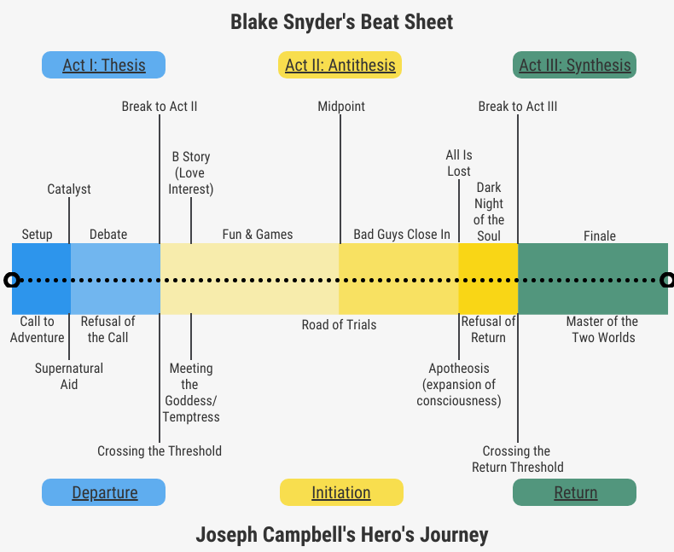
(This infographic is a quick reminder of the basic story beats for the three-act structure. These can be used for each story individually, as well as overarching stories that take place over multiple books or episodes within a series. If you’d like to learn more about using this structure for larger scale stories, I have blog posts about it here, here, and here).

Overarching Story Beats
Setup:
Catalyst/Inciting Incident:
Debate:
Break to Act II:
B-Story:
Fun and Games:
Midpoint:
Bad Guys Close In:
All Is Lost:
Dark Night of the Soul:
Finale:

Story One Beats
Setup:
Catalyst/Inciting Incident:
Debate:
Break to Act II:
B-Story:
Fun and Games:
Midpoint:
Bad Guys Close In:
All Is Lost:
Dark Night of the Soul:
Finale:

Story Two Beats
Setup:
Catalyst/Inciting Incident:
Debate:
Break to Act II:
B-Story:
Fun and Games:
Midpoint:
Bad Guys Close In:
All Is Lost:
Dark Night of the Soul:
Finale:

Story BLANK Beats
Setup:
Catalyst/Inciting Incident:
Debate:
Break to Act II:
B-Story:
Fun and Games:
Midpoint:
Bad Guys Close In:
All Is Lost:
Dark Night of the Soul:
Finale:

Lexicon

Word One – Definition.

Word Two – Definition.

Word Three – Definition.

Word BLANK – Definition.

Geography

Continent Name(s):

Region One (Name goes here):
Real-World Analogue(s):
Climate:
Biomes:
Defining Characteristic(s):
Capitals:
Additional Information:

Region Two (Name goes here):
Real-World Analogue(s):
Climate:
Biomes:
Defining Characteristic(s):
Capitals:
Additional Information:

Region BLANK (Name goes here):
Real-World Analogue(s):
Climate:
Biomes:
Defining Characteristic(s):
Capitals:
Additional Information:

Factions

Faction One (Name goes here)
Core Concept:
Role in Story:
Size/Number of Members:
Hierarchy:
Shared Goal:
Leaders:
Rituals/Codes of Behavior:
Additional Information:

Faction Two (Name goes here)
Core Concept:
Role in Story:
Size/Number of Members:
Hierarchy:
Shared Goal:
Leaders:
Rituals/Codes of Behavior:
Additional Information:

Faction BLANK (Name goes here)
Core Concept:
Role in Story:
Size/Number of Members:
Hierarchy:
Shared Goal:
Leaders:
Rituals/Codes of Behavior:
Additional Information:

Other Nations

Minor Locations

Location One
Defining Characteristic(s):
Additional Information:

Location Two
Defining Characteristic(s):
Additional Information:

Location Three
Defining Characteristic(s):
Additional Information:

Location Four
Defining Characteristic(s):
Additional Information:

Location BLANK
Defining Characteristic(s):
Additional Information:

Timeline

World Creation Myth:

Ancient History:

Regional History:

Modern History:

Additional Notes

Backup Blanks

Fantasy Conceit BLANK
- Core Concept/Defining Criteria:
- Appearance:
- Abilities:
- Frequency:
- History:
- Additional Information:
Analogue Culture BLANK
- What real-world culture will you draw from?
- What time period(s) within that culture will you use?
- What are the defining characteristics of that culture at that time?
- What aspects will you use for your world and story?
- How will you change these aspects with your fantasy conceits?
- Additional Information:
Analogue Culture BLANK (Name goes here) Write-Up:

Major Character BLANK
Role in story:
Physical description:
History:
Personality:
Arc(s):
Additional information:

Story BLANK Beats
Setup:
Catalyst/Inciting Incident:
Debate:
Break to Act II:
B-Story:
Fun and Games:
Midpoint:
Bad Guys Close In:
All Is Lost:
Dark Night of the Soul:
Finale:

Word BLANK – Definition.

Region BLANK (Name goes here):
Real-World Analogue(s):
Climate:
Biomes:
Defining Characteristic(s):
Capitals:
Additional Information:

Faction BLANK (Name goes here)
Core Concept:
Role in Story:
Size/Number of Members:
Hierarchy:
Shared Goal:
Leaders:
Rituals/Codes of Behavior:
Additional Information:

Minor Location BLANK
Defining Characteristic(s):
Additional Information:

